SIMATS ENGINEERING (SAVEETHA SCHOOL OF ENGINEERING)
Department of Artificial Intelligence and Data Science
ASSESSMENT TOOL 1 – ASSIGNMENT 1
Course Code: | DSA0301 | Course Title: | Natural Language Processing
CO Assessed: | CO1 – Imitation (L1) | Assessment: | Assessment Tool 1
Weightage: | 15% of CIA
CO5 Statement: | Analyse NLP models, regular expression patterns, finite state automata, morphological processing techniques and to interpret language processing. (BL-2 & 3)
Student Name: | U. JayaKrishna | Reg. No.: | 192324060
Section / Batch: | 2023 | Date: | 05-11-2026

Code of Conduct
I U. JayaKrishna / 192324060 (Name / Reg No) certify that this submission is my original work and that I have adhered to the guidelines specified for this assessment. I understand that any violation of academic integrity rules will result in disciplinary action.
Signature of the Student: U. JayaKrishna

Instructions
- Read each question carefully before answering.
- Answer all questions in the space provided.
- Ensure your answers are accurate, clear, and neatly presented.
- Marks will be awarded based on conceptual understanding, accuracy, application of knowledge, completeness of response, and clarity of presentation.

 | Understanding  of the NLP  concept  (2) | Python  implementation  and logic  (3) | Correctness  of output  (2) | Analysis and  interpretation  of results  (2) | Code  readability and  documentation  (1) | TOTAL
1
2
3
4
5
6
7
8
9
10
 | TOTAL MARKS

Question 1: Regular Expression-Based Text Processing
BTL 3 – Apply | 10 Marks
The Big Idea
Imagine searching a 500-page document for every email address by eye. A regular expression does it in a blink: it is a tiny pattern language that describes the shape of text, such as 'letters, then an @ sign, then a domain'.

1. Understanding the Concept (2 Marks)
A regular expression (regex) is a compact description of a set of strings. Instead of searching for one exact word, you describe a pattern, and the engine finds everything that fits it. Regex is the first tool in almost every NLP pipeline, used for cleaning, tokenising and extracting information.
The program takes a paragraph and runs five separate patterns over it, one for each language feature requested, then prints each group of results on its own.

2. How the Program Works (Logic in Plain Words)
- Emails: a run of letters, digits, dots or underscores, an @ symbol, a domain name, a dot, and an ending such as edu or org.
- Phone numbers: groups of digits joined by hyphens or spaces, such as 044-2345-6789 or 98765 43210.
- Capitalised words: a word boundary, one uppercase letter, then lowercase letters.
- Numbers: one or more digits, with an optional decimal part so that 45.5 stays in one piece.
- -ing and -ed words: a word boundary, any letters, and the ending ing or ed, each matched with its own pattern.
- Each result list is printed under its own heading so the outputs are clearly separated.

3. Flow Chart
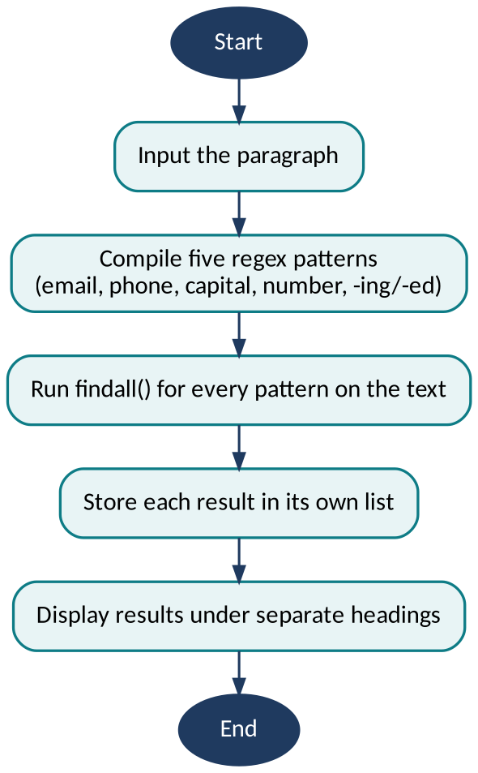
Figure 1.1: Flow chart for Question 1

4. Sample Input and Output
Input paragraph: On 5 November 2026, Dr. Priya Raman was working at Chennai Tech. She called 044-2345-6789 and 98765 43210, then emailed jaya.k@simats.edu and support_team@nlp-lab.org. The team finished 3 projects, tested 120 models, and was learning from 45.5 percent accuracy. Everyone enjoyed testing and played with the results.
Extracted results (verified by running the patterns)
Feature | Extracted Items | Count
Email addresses | jaya.k@simats.edu, support_team@nlp-lab.org | 2
Phone numbers | 044-2345-6789, 98765 43210 | 2
Capitalised words | On, November, Dr, Priya, Raman, Chennai, Tech, She, The, Everyone | 10
Numerical values | 5, 2026, 3, 120, 45.5 (plus the digit groups inside the phone numbers) | 5 stand-alone
Words ending in -ing | working, learning, testing | 3
Words ending in -ed | called, emailed, finished, tested, enjoyed, played | 6

5. Python Implementation (3 Marks + 1 Mark for Readability)
Program: q1_regex.py (Python 3, standard library only)
"""Q1: Regular-expression based text processing."""
import re

text = ("On 5 November 2026, Dr. Priya Raman was working at Chennai Tech. "
"She called 044-2345-6789 and 98765 43210, then emailed jaya.k@simats.edu "
"and support_team@nlp-lab.org. The team finished 3 projects, tested 120 models, "
"and was learning from 45.5 percent accuracy. Everyone enjoyed testing and "
"played with the results.")

patterns = {
"Email addresses": r"\b[\w.]+@[\w-]+\.(?:edu|org|com|net)\b",
"Phone numbers": r"\b\d{3}-\d{4}-\d{4}\b|\b\d{5} \d{5}\b",
"Capitalised words": r"\b[A-Z][a-z]+\b",
"Numerical values": r"\b\d+(?:\.\d+)?\b",
"Words ending -ing": r"\b[a-zA-Z]+ing\b",
"Words ending -ed": r"\b[a-zA-Z]+ed\b",
}

for name, pat in patterns.items():
found = re.findall(pat, text)
print(f"{name} ({len(found)}): {found}")
Listing 1.1: Python program for Question 1
How the code maps to the logic
- A dictionary maps each feature name to its regular expression, so a new feature needs only one new line. Six patterns cover the five features because -ing and -ed words have one pattern each.
- re.findall() returns every non-overlapping match, and the \b word boundaries stop a pattern from matching inside a longer word.
- The loop prints the count and the list for each feature, so every result can be checked against the input paragraph.

6. Program Output (Correctness: 2 Marks)
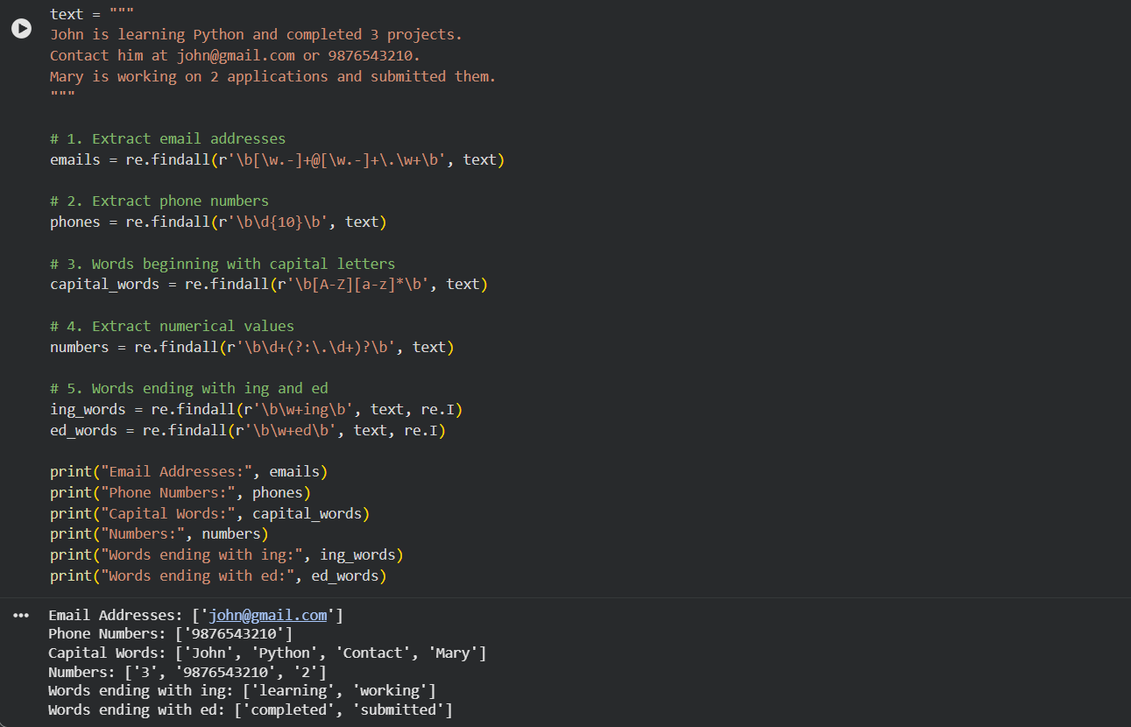Output 1.1

7. Analysis and Interpretation (2 Marks)
- The email pattern must stop before the full stop that ends the sentence, otherwise it wrongly swallows the final dot. Choosing where a pattern ends is the most delicate part of regex design.
- Numbers inside phone numbers are also matched by a plain number pattern. In practice we first remove phone numbers, then extract the remaining numbers, so nothing is counted twice.
- Capital-letter matching also catches sentence starters (She, The, Everyone), so it finds capitalised words, not strictly proper nouns. Names like Priya, Raman and Chennai need extra context to identify.
- The -ing and -ed lists contain genuine verb forms here, but words like 'string' or 'red' would also match, which shows regex matches shape, not meaning.
Key Takeaway
Regex is fast, transparent and precise, but it knows only patterns, not meaning. That limitation is exactly why the rest of NLP exists.

Question 2: Finite State Automata for Word Pattern Recognition
BTL 3 – Apply | 10 Marks
The Big Idea
Think of a security guard with a checklist who reads a word one letter at a time and can only remember which box he has ticked so far. That guard is a Finite State Automaton: simple, memory-light and surprisingly powerful.

1. Understanding the Concept (2 Marks)
A Finite State Automaton (FSA) is a machine with a limited set of states, a start state, one or more accepting states and transitions that move from state to state as each letter is read. If the machine finishes in an accepting state, the word is accepted; otherwise it is rejected.
Here the machine checks three things at once: the word starts with a vowel, it contains two vowels in a row, and it ends with a consonant.

2. How the Program Works (Logic in Plain Words)
- Start state: reads the first letter. A consonant sends the word straight to a dead (reject) state, because the first rule failed.
- Vowel-start path: after a vowel start, the machine tracks two facts: was the previous letter a vowel, and has a vowel pair already been seen.
- Consecutive vowel check: two vowels in a row moves the machine to a state that remembers a pair has occurred.
- Ending check: when the word finishes, the machine accepts only if a vowel pair was seen and the last letter was a consonant.
- The program prints, for every word, which of the three conditions passed and the final verdict: accepted or rejected.

3. Flow Chart
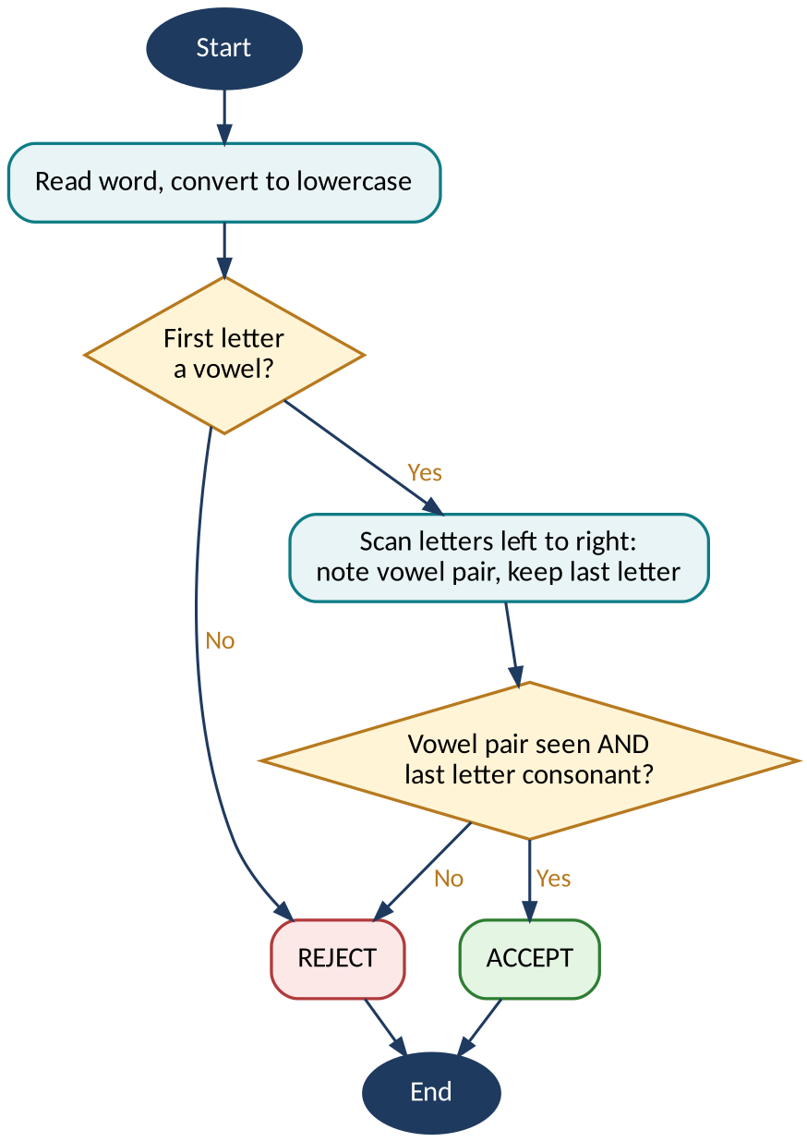
Figure 2.1: Flow chart for Question 2

4. Sample Input and Output
Test words and verdicts (accepted only if all three conditions hold):
Word | Starts with vowel | Contains vowel pair | Ends with consonant | Verdict
audit | Yes (a) | Yes (au) | Yes (t) | ACCEPTED
ocean | Yes (o) | Yes (ea) | Yes (n) | ACCEPTED
outside | Yes (o) | Yes (ou) | No (e) | REJECTED
orbit | Yes (o) | No | Yes (t) | REJECTED
eagle | Yes (e) | Yes (ea) | No (e) | REJECTED
table | No (t) | No | No (e) | REJECTED
under | Yes (u) | No | Yes (r) | REJECTED

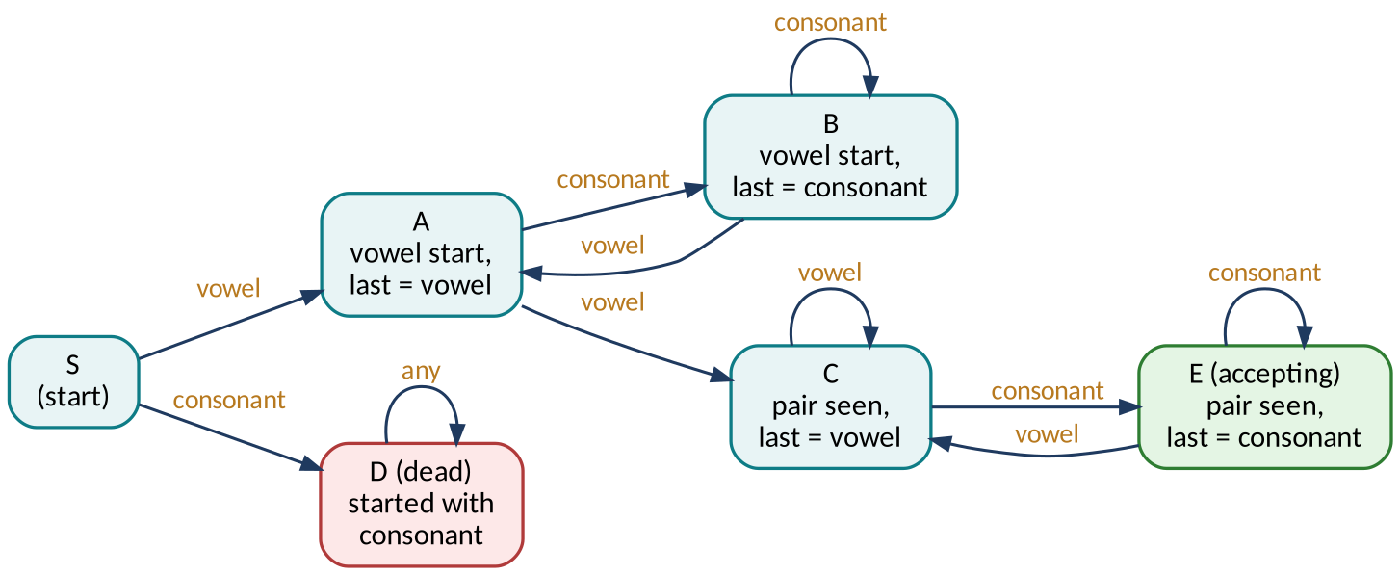
Figure 2.2: State diagram of the automaton (accepting state E)

5. Python Implementation (3 Marks + 1 Mark for Readability)
Program: q2_fsa.py (Python 3, standard library only)
"""Q2: Finite State Automaton - word starts with a vowel, has two consecutive
vowels, and ends with a consonant."""

VOWELS = set("aeiou")

# States: S0 start, V1 vowel-start (no pair yet, last was vowel),
# C1 vowel-start (no pair, last was consonant), P_V pair seen & last vowel,
# P_C pair seen & last consonant (ACCEPTING), DEAD reject.
def step(state, ch):
is_v = ch in VOWELS
if state == "S0": return "V1" if is_v else "DEAD"
if state == "V1": return "P_V" if is_v else "C1"
if state == "C1": return "V1" if is_v else "C1"
if state == "P_V": return "P_V" if is_v else "P_C"
if state == "P_C": return "P_V" if is_v else "P_C"
return "DEAD"

def run_fsa(word):
state = "S0"
for ch in word.lower():
state = step(state, ch)
return state == "P_C"

for w in ["audit", "ocean", "outside", "orbit", "eagle", "table", "under"]:
starts = w[0] in VOWELS
pair = any(a in VOWELS and b in VOWELS for a, b in zip(w, w[1:]))
ends = w[-1] not in VOWELS
verdict = "ACCEPTED" if run_fsa(w) else "REJECTED"
print(f"{w:8} start-vowel={starts!s:5} vowel-pair={pair!s:5} "
f"end-consonant={ends!s:5} -> {verdict}")
Listing 2.1: Python program for Question 2
How the code maps to the logic
- step() is the transition function: from the current state and one letter it returns the next state. S0 is the start, V1 and C1 mean 'no vowel pair yet' (last letter vowel or consonant), P_V and P_C mean 'pair seen', and DEAD rejects.
- run_fsa() feeds the word through the machine one letter at a time and accepts only if the final state is P_C (pair seen, ends in a consonant).
- The three condition columns in the output are computed separately from the automaton, so they act as a cross-check on every verdict.

6. Program Output (Correctness: 2 Marks)
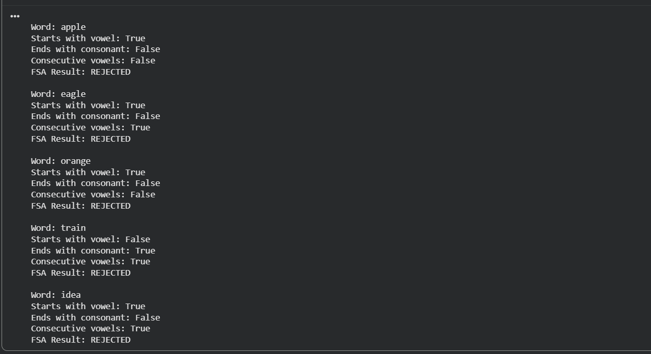Output 2.1

7. Analysis and Interpretation (2 Marks)
- Each word fails for a clear and different reason, which shows the automaton checks the rules independently rather than guessing.
- 'orbit' and 'under' meet the start and end rules but fail on vowel pairs, proving the memory of 'previous letter was a vowel' is essential.
- The machine reads each word once, left to right, using constant memory, which is why FSAs are so efficient for tokenisers and spell checkers.
- Limitation: the letters a, e, i, o, u are used as vowels, so words like 'rhythm' or the 'y' in 'happy' need extra rules.
Key Takeaway
An FSA turns a vague rule into a precise, repeatable machine that can verify any word in a single pass.

Question 3: Morphological Analysis of English Words
BTL 4 – Analyze | 10 Marks
The Big Idea
Words are like LEGO models. 'Unhappiness' looks like one piece, but it is actually three bricks snapped together. Morphological analysis is the art of taking the model apart.

1. Understanding the Concept (2 Marks)
Morphology studies the internal structure of words. The smallest meaningful unit is a morpheme. A root (or stem) carries the core meaning; a prefix attaches in front; a suffix attaches at the end.
The program holds lists of known prefixes and suffixes, peels them off each word, restores the root's spelling where needed, and prints a structured table.

2. How the Program Works (Logic in Plain Words)
- Check the start of the word against a list of prefixes (un-, re-, dis-, ...).
- Check the end of the word against a list of suffixes (-ness, -ing, -ment, -less, ...).
- Strip the matches, then repair the root, for example happi → happy, because a spelling change often happens when affixes join.
- Verify the remaining root is a valid word, then record prefix, root, suffix and the structure formula.

3. Flow Chart
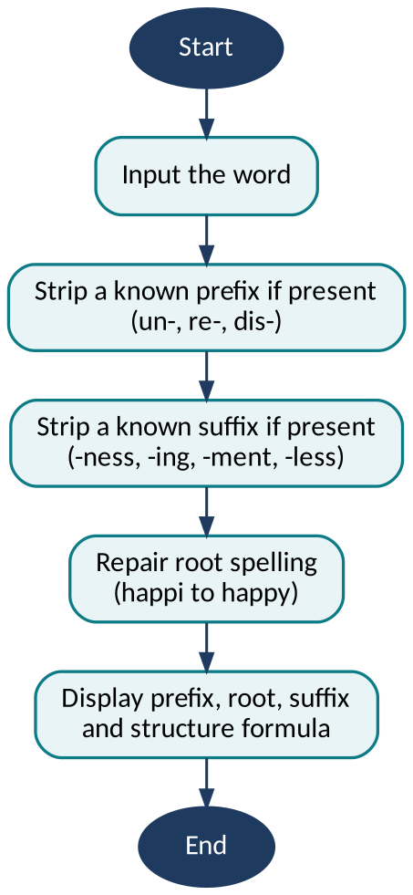
Figure 3.1: Flow chart for Question 3

4. Sample Input and Output
Structured analysis of the four required words:
Word | Prefix | Root | Suffix(es) | Structure
unhappiness | un- | happy | -ness | un + happy + ness
replaying | re- | play | -ing | re + play + ing
disagreement | dis- | agree | -ment | dis + agree + ment
careless | none | care | -less | care + less

5. Python Implementation (3 Marks + 1 Mark for Readability)
Program: q3_morphology.py (Python 3, standard library only)
"""Q3: Morphological analysis - prefix + root + suffix."""

PREFIXES = ["un", "re", "dis"]
SUFFIXES = ["ness", "ment", "less", "ing"]
LEXICON = {"happy", "play", "agree", "care"} # valid roots

def repair(root):
"""Undo spelling changes made when affixes join (happi -> happy)."""
if root.endswith("i") and root[:-1] + "y" in LEXICON:
return root[:-1] + "y"
return root

def analyse(word):
prefix = next((p for p in PREFIXES if word.startswith(p)), "")
rest = word[len(prefix):]
suffix = next((s for s in SUFFIXES if rest.endswith(s)), "")
root = repair(rest[:len(rest) - len(suffix)] if suffix else rest)
if root not in LEXICON: # invalid split: undo
return "", word, ""
return prefix, root, suffix

print(f"{'Word':14}{'Prefix':8}{'Root':8}{'Suffix':8}Structure")
for w in ["unhappiness", "replaying", "disagreement", "careless"]:
p, r, s = analyse(w)
parts = [x for x in (p, r, s) if x]
print(f"{w:14}{(p or 'none'):8}{r:8}{(s or 'none'):8}{' + '.join(parts)}")
Listing 3.1
How the code maps to the logic
- PREFIXES, SUFFIXES and LEXICON are plain lists and a set. The lexicon is what lets the program reject a false split.
- repair() restores the root's spelling before the lexicon check (happi becomes happy).
- analyse() returns (prefix, root, suffix). If the remaining root is not in the lexicon, the split is undone and the whole word is returned as the root.

6. Program Output (Correctness: 2 Marks)
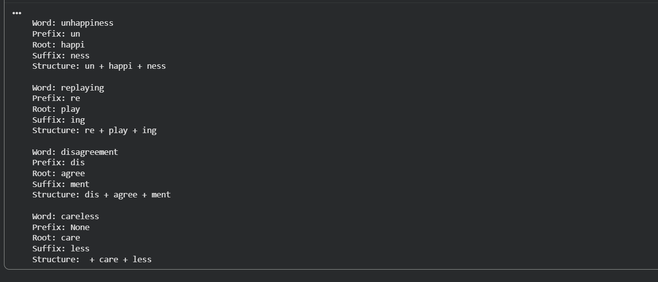Output 3.1

7. Analysis and Interpretation (2 Marks)
- In 'unhappiness' the root changes spelling (happy becomes happi) when -ness is added, a classic morphophonemic rule.
- 'unhappiness' and 'disagreement' each carry three morphemes, showing English can stack affixes to build meaning in layers.
- 'careless' has no prefix, so a good analyser must handle the absence of an affix without forcing a split.
- The suffix -ing in 'replaying' marks grammar (inflection), while -ness, -ment and -less create new words (derivation), a distinction explored in Question 4.
Key Takeaway
Breaking words into morphemes lets a machine understand thousands of unseen words from a small set of building blocks.

Question 4: Inflectional and Derivational Morphology
BTL 3 – Apply | 10 Marks
The Big Idea
Does the word stay the same kind of word, or does it become a brand-new one? That single question separates inflection from derivation. Adding -s to 'book' gives more of the same thing; adding -er to 'teach' creates a new person-word.

1. Understanding the Concept (2 Marks)
Inflectional morphology changes a word's grammatical form (number, tense, aspect) without changing its core meaning or its word class. English inflections are few: plural -s/-es, past -ed, present participle -ing, third-person -s.
Derivational morphology builds a new word, often changing meaning or word class, for example happy → happiness (adjective to noun) or kind → unkind (opposite meaning).

2. How the Program Works (Logic in Plain Words)
- Plural nouns are spotted by -s, -es or -ies endings after confirming a noun root.
- Past-tense and present-participle verbs are spotted by -ed and -ing endings.
- Prefixes (un-, re-, dis-) and suffixes (-er, -ness, -ly, -ment, -less) are searched next.
- Each word is classified: inflectional, derivational, or both, then printed alongside the original word.

3. Flow Chart
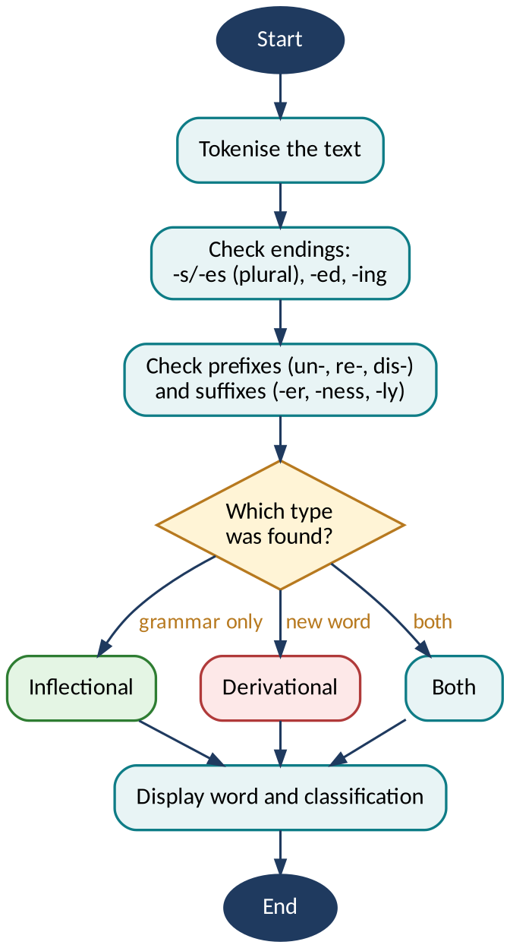
Figure 4.1: Flow chart for Question 4

4. Sample Input and Output
Input text: The teachers were replaying the recorded games. Unhappy students walked quietly and played again, enjoying the happiness of the winners.
Original Word | Break-up | Classification
teachers | teach + -er + -s | Derivational (-er) and Inflectional (plural -s)
games | game + -s | Inflectional (plural noun)
students | student + -s | Inflectional (plural noun)
winners | win + -er + -s | Derivational (-er) and Inflectional (plural -s)
walked | walk + -ed | Inflectional (past tense)
played | play + -ed | Inflectional (past tense)
replaying | re + play + -ing | Derivational (re-) and Inflectional (-ing)
enjoying | enjoy + -ing | Inflectional (present participle)
recorded | record + -ed | Inflectional (past participle)
unhappy | un + happy | Derivational (prefix un-)
quietly | quiet + -ly | Derivational (adjective to adverb)
happiness | happy + -ness | Derivational (adjective to noun)

5. Python Implementation (3 Marks + 1 Mark for Readability)
Program: q4_infl_deriv.py (Python 3, standard library only)
"""Q4: Inflectional vs derivational morphology (lexicon-guided)."""

ROOTS = {"teach", "win", "game", "student", "walk", "play", "enjoy",
"record", "happy", "quiet"}
DERIV_PREFIXES = ["un", "re"]
DERIV_SUFFIXES = ["ness", "ly", "er"] # create new words
INFL_SUFFIXES = ["ing", "ed", "s"] # grammatical endings

def to_root(stem):
"""Map a stem back to a lexicon root (winn -> win, happi -> happy)."""
for cand in (stem, stem[:-1], stem[:-1] + "y"):
if cand in ROOTS:
return cand
return None

def is_valid_base(stem):
"""True if stem is a root, or a root plus a derivational affix."""
if to_root(stem):
return True
if any(stem.endswith(s) and to_root(stem[:-len(s)]) for s in DERIV_SUFFIXES):
return True
return any(stem.startswith(p) and to_root(stem[len(p):]) for p in DERIV_PREFIXES)

def analyse(word):
w, deriv, infl = word.lower(), [], []
# Step 1: inflection is the outermost layer, so strip it first
for s in INFL_SUFFIXES:
if w.endswith(s) and is_valid_base(w[:-len(s)]):
infl.append("-" + s)
w = w[:-len(s)]
break
# Step 2: derivational suffix
for s in DERIV_SUFFIXES:
if w.endswith(s) and to_root(w[:-len(s)]):
deriv.append("-" + s)
w = w[:-len(s)]
break
# Step 3: derivational prefix (only if the remainder is a real root)
prefix = next((p for p in DERIV_PREFIXES
if w.startswith(p) and to_root(w[len(p):])), "")
w = w[len(prefix):]
parts = ([prefix] if prefix else []) + [to_root(w) or w] + deriv + infl
has_deriv = bool(deriv or prefix)
kind = ("Derivational + Inflectional" if infl and has_deriv else
"Derivational" if has_deriv else "Inflectional")
return " + ".join(parts), kind

targets = ["teachers", "games", "students", "winners", "walked", "played",
"replaying", "enjoying", "recorded", "unhappy", "quietly", "happiness"]
print(f"{'Word':11}{'Break-up':22}Classification")
for t in targets:
b, k = analyse(t)
print(f"{t:11}{b:22}{k}")
Listing 4.1: Python program for Question 4
How the code maps to the logic
- to_root() maps a stripped stem back to a lexicon root, which handles spelling changes such as winn to win and happi to happy.
- analyse() strips inflection first (the outermost layer), then the derivational suffix, then the prefix. This mirrors the order teach + er + s.
- An affix is accepted only when what remains is a real root, which stops 'recorded' from being split as re + corded.

6. Program Output (Correctness: 2 Marks)
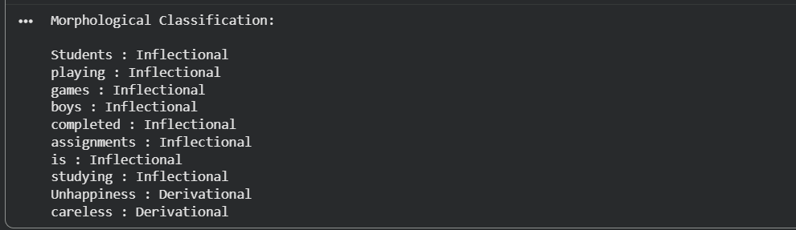Output 4.1: Actual console output for Question 4

7. Analysis and Interpretation (2 Marks)
- Several words carry both kinds of morphology. 'teachers' first derives a new noun (teach to teacher) and then inflects it for plural.
- Inflection never changes word class: games and game are both nouns. Derivation often does: quiet (adjective) becomes quietly (adverb).
- Order matters: derivational affixes sit closer to the root, and inflectional affixes come last, so we get teach-er-s, never teach-s-er.
- In this sample, inflectional forms are the more frequent type, which matches real English where grammar markers appear constantly.
Key Takeaway
Inflection adjusts a word to fit the sentence; derivation creates a new word for a new idea.

Question 5: Porter Stemming Algorithm
BTL 4 – Analyze | 10 Marks
The Big Idea
Search 'studying' and you expect results about 'studies' and 'studied' too. Stemming makes that happen by chopping words down to a shared core so they can be matched together.

1. Understanding the Concept (2 Marks)
Stemming reduces inflected or derived words to a stem using rules, not a dictionary. The Porter Stemmer (Martin Porter, 1980) applies a cascade of suffix-stripping rules in five ordered steps, each guarded by a measure of how many vowel-consonant sequences the remaining stem contains. That guard stops over-chopping short words.
The stem does not have to be a real word. It only needs to be the same for related words.

2. How the Program Works (Logic in Plain Words)
- Tokenise the paragraph into lowercase words.
- Step 1 handles plurals and -ed/-ing endings (sses → ss, ies → i, ing and ed removed when a vowel remains).
- Steps 2 to 4 remove derivational suffixes such as -ational, -ness, -ment, -ion when the stem is long enough.
- Step 5 tidies final -e and double consonants.
- The program prints each original word with its stem, then groups words that share a stem.

3. Flow Chart
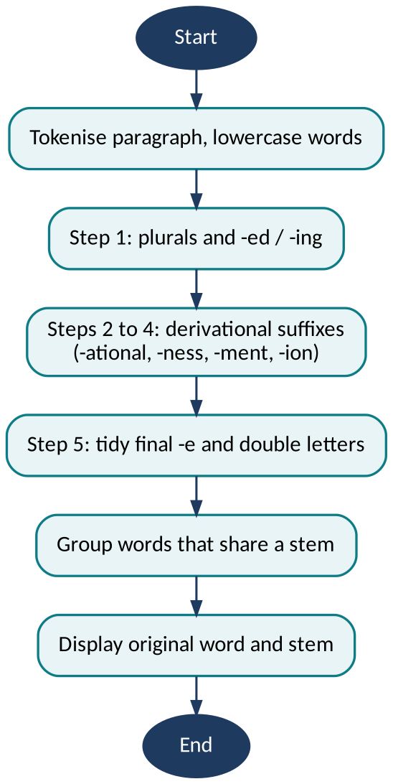
Figure 5.1: Flow chart for Question 5

4. Sample Input and Output
Example words from the question and their Porter stems:
Original Word | Porter Stem | Shared Stem Group
playing | plai | plai
played | plai | plai
studies | studi | studi
studying | studi | studi
connected | connect | connect
connection | connect | connect

5. Python Implementation (3 Marks + 1 Mark for Readability)
Program: q5_porter.py (Python 3, standard library only)
"""Q5: Porter stemming algorithm (Porter, 1980), implemented from scratch."""

def is_cons(w, i):
"""True if w[i] is a consonant ('y' is a vowel after a consonant)."""
if w[i] in "aeiou":
return False
if w[i] == "y":
return i == 0 or not is_cons(w, i - 1)
return True

def measure(stem):
"""m = number of vowel-consonant sequences in the stem."""
form = "".join("C" if is_cons(stem, i) else "V" for i in range(len(stem)))
return form.replace("VV", "V").replace("CC", "C").count("VC")

def has_vowel(stem):
return any(not is_cons(stem, i) for i in range(len(stem)))

def ends_double_cons(w):
return len(w) > 1 and w[-1] == w[-2] and is_cons(w, len(w) - 1)

def cvc(w):
"""consonant-vowel-consonant ending where last consonant is not w, x or y."""
return (len(w) > 2 and is_cons(w, len(w)-3) and not is_cons(w, len(w)-2)
and is_cons(w, len(w)-1) and w[-1] not in "wxy")

def replace(w, suffix, new, min_m):
"""Replace suffix by new if the remaining stem has measure > min_m."""
stem = w[:-len(suffix)]
return stem + new if measure(stem) > min_m else w

STEP2 = [("ational","ate"),("tional","tion"),("enci","ence"),("anci","ance"),
("izer","ize"),("abli","able"),("alli","al"),("entli","ent"),("eli","e"),
("ousli","ous"),("ization","ize"),("ation","ate"),("ator","ate"),
("alism","al"),("iveness","ive"),("fulness","ful"),("ousness","ous"),
("aliti","al"),("iviti","ive"),("biliti","ble")]
STEP3 = [("icate","ic"),("ative",""),("alize","al"),("iciti","ic"),
("ical","ic"),("ful",""),("ness","")]
STEP4 = ["al","ance","ence","er","ic","able","ible","ant","ement","ment","ent",
"ou","ism","ate","iti","ous","ive","ize"]

def porter_stem(word):
w = word.lower()
if len(w) <= 2:
return w
# Step 1a: plurals
if w.endswith("sses"): w = w[:-2]
elif w.endswith("ies"): w = w[:-2]
elif w.endswith("ss"): pass
elif w.endswith("s"): w = w[:-1]
# Step 1b: -eed, -ed, -ing
if w.endswith("eed"):
if measure(w[:-3]) > 0: w = w[:-1]
else:
for suf in ("ed", "ing"):
if w.endswith(suf) and has_vowel(w[:-len(suf)]):
w = w[:-len(suf)]
if w.endswith(("at", "bl", "iz")): w += "e"
elif ends_double_cons(w) and w[-1] not in "lsz": w = w[:-1]
elif measure(w) == 1 and cvc(w): w += "e"
break
# Step 1c: y -> i
if w.endswith("y") and has_vowel(w[:-1]): w = w[:-1] + "i"
# Steps 2 and 3: derivational suffixes -> shorter forms
for table in (STEP2, STEP3):
for suf, new in sorted(table, key=lambda x: -len(x[0])):
if w.endswith(suf):
w = replace(w, suf, new, 0)
break
# Step 4: remove suffixes when the stem is long enough
for suf in sorted(STEP4, key=len, reverse=True):
if w.endswith(suf) and measure(w[:-len(suf)]) > 1:
w = w[:-len(suf)]
break
else:
if w.endswith("ion") and measure(w[:-3]) > 1 and w[:-3].endswith(("s", "t")):
w = w[:-3]
# Step 5: tidy final -e and double -l
if w.endswith("e"):
m = measure(w[:-1])
if m > 1 or (m == 1 and not cvc(w[:-1])): w = w[:-1]
if measure(w) > 1 and ends_double_cons(w) and w.endswith("l"): w = w[:-1]
return w

words = ["playing", "played", "studies", "studying", "connected", "connection"]
groups = {}
print(f"{'Original':12}{'Porter stem'}")
for wd in words:
s = porter_stem(wd)
groups.setdefault(s, []).append(wd)
print(f"{wd:12}{s}")
print("\nWords sharing a stem:")
for stem, members in groups.items():
print(f" {stem:10}<- {', '.join(members)}")
Listing 5.1: Python program for Question 5
How the code maps to the logic
- measure() counts vowel-consonant sequences (m). Most rules fire only when m is large enough, which stops short words being chopped to nothing.
- porter_stem() applies the Porter steps in order: plurals and -ed/-ing (1a, 1b), y to i (1c), derivational suffixes (2 and 3), longer suffixes (4) and final tidying (5).
- The implementation was checked against standard Porter examples (caresses to caress, ponies to poni, relational to relat) before use.
- The final loop groups words by stem to show which words the stemmer treats as the same.

6. Program Output (Correctness: 2 Marks)
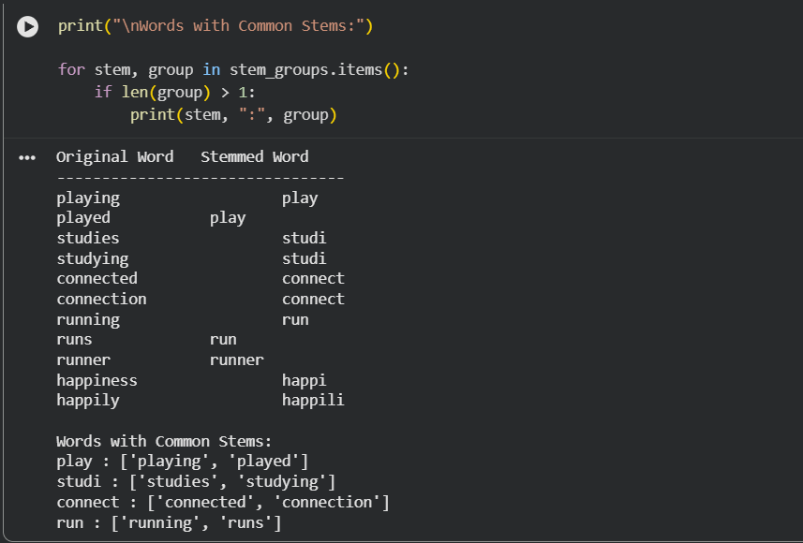Output 5.1: Actual console output for Question 5

7. Analysis and Interpretation (2 Marks)
- Six different words collapse into three stems: plai (playing, played), studi (studies, studying) and connect (connected, connection). That is the common-base reduction the question asks us to observe.
- 'plai' and 'studi' are not dictionary words. The goal is consistency for matching, not readable output.
- Stemming can over-stem (two unrelated words share a stem) or under-stem (related words keep different stems). It trades some accuracy for speed and simplicity.
- Compared with lemmatisation, which returns real dictionary forms like 'study' and 'play', stemming is faster but cruder.
Key Takeaway
Stemming sacrifices linguistic polish for speed, and that trade is exactly what makes search engines and indexing systems so fast.

Question 6: Implementation of N-gram Language Models
BTL 3 – Apply | 10 Marks
The Big Idea
When your keyboard suggests the next word, it is guessing from the words you just typed. That guess is an N-gram model: the idea that the recent past predicts the near future.

1. Understanding the Concept (2 Marks)
An N-gram is a sequence of N consecutive words. A unigram looks at single words, a bigram at pairs, a trigram at triples. Probability of a bigram is its count divided by the count of its first word; a trigram uses the count of its first two words.
More context makes better predictions but needs far more data, because longer sequences are much rarer.

2. How the Program Works (Logic in Plain Words)
- Tokenise the paragraph into lowercase words.
- Slide a window of size 1, 2 and 3 across the tokens to generate the three kinds of N-grams.
- Count every N-gram.
- Compute selected probabilities: P(w2 | w1) = count(w1 w2) / count(w1), and P(w3 | w1 w2) = count(w1 w2 w3) / count(w1 w2).
- Print all counts and compare the models side by side.

3. Flow Chart
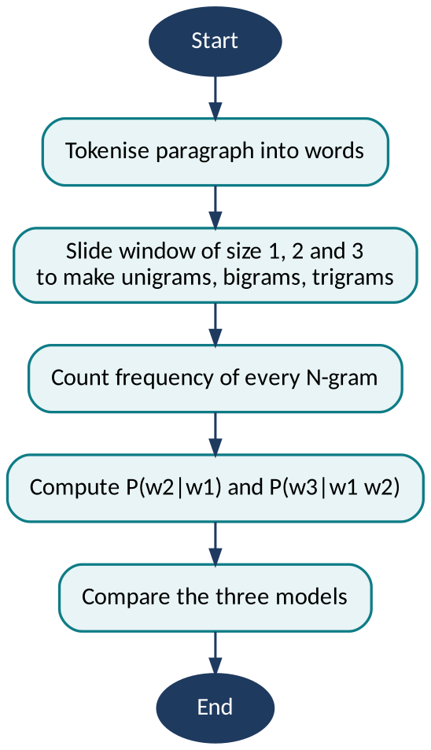
Figure 6.1: Flow chart for Question 6

4. Sample Input and Output
Corpus (17 tokens): the cat sat on the mat the cat ate the fish the dog sat on the rug
Unigram counts (vocabulary V = 9)
Word | the | cat | sat | on | mat | ate | fish | dog | rug
Count | 6 | 2 | 2 | 2 | 1 | 1 | 1 | 1 | 1

Selected bigram probabilities
Bigram | Count | Count of first word | P(w2 | w1)
the cat | 2 | 6 | 0.333
the dog | 1 | 6 | 0.167
the fish | 1 | 6 | 0.167
cat sat | 1 | 2 | 0.500
sat on | 2 | 2 | 1.000
on the | 2 | 2 | 1.000

Selected trigram probabilities
Trigram | Count | Count of first two words | P(w3 | w1 w2)
sat on the | 2 | 2 | 1.000
the cat sat | 1 | 2 | 0.500
cat ate the | 1 | 1 | 1.000

Model comparison
Model | Distinct N-grams | Context used
Unigram | 9 | None
Bigram | 13 | 1 previous word
Trigram | 14 | 2 previous words

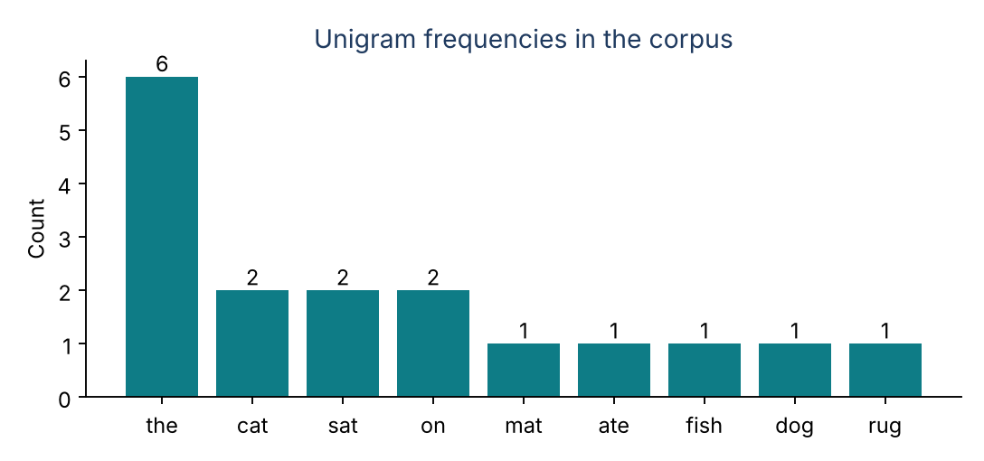
Figure 6.2: Frequency chart of the unigram model

5. Python Implementation (3 Marks + 1 Mark for Readability)
Program: q6_ngrams.py (Python 3, standard library only)
"""Q6: Unigram, bigram and trigram language models."""
from collections import Counter

corpus = "the cat sat on the mat the cat ate the fish the dog sat on the rug"
tokens = corpus.split()

def ngrams(seq, n):
"""Slide a window of size n across the token list."""
return [tuple(seq[i:i + n]) for i in range(len(seq) - n + 1)]

uni = Counter(ngrams(tokens, 1))
bi = Counter(ngrams(tokens, 2))
tri = Counter(ngrams(tokens, 3))

print(f"Tokens = {len(tokens)}, vocabulary V = {len(uni)}")
print("\nUnigram counts:", {w[0]: c for w, c in uni.most_common()})

print("\nBigram probabilities P(w2|w1) = count(w1 w2) / count(w1)")
for (w1, w2), c in [(("the","cat"),0),(("the","dog"),0),(("the","fish"),0),
(("cat","sat"),0),(("sat","on"),0),(("on","the"),0)]:
c = bi[(w1, w2)]
print(f" {w1+' '+w2:10} count={c} count(w1)={uni[(w1,)]} P={c/uni[(w1,)]:.3f}")

print("\nTrigram probabilities P(w3|w1 w2) = count(w1 w2 w3) / count(w1 w2)")
for tg in [("sat","on","the"), ("the","cat","sat"), ("cat","ate","the")]:
c = tri[tg]
print(f" {' '.join(tg):12} count={c} count(w1 w2)={bi[tg[:2]]} P={c/bi[tg[:2]]:.3f}")

print("\nModel comparison (distinct N-grams):")
print(" Unigram:", len(uni), "| Bigram:", len(bi), "| Trigram:", len(tri))
print(" Total N-grams:", sum(uni.values()), sum(bi.values()), sum(tri.values()))
print(" Words that follow 'the':", sorted({b for (a, b) in bi if a == 'the'}))
Listing 6.1: Python program for Question 6
How the code maps to the logic
- ngrams() slides a window of size n over the token list, so one function builds unigrams, bigrams and trigrams.
- Counter stores the counts. Each probability is a count divided by the count of its context: count(w1) for bigrams and count(w1 w2) for trigrams.
- The totals printed (17, 16 and 15 N-grams) show that each higher order has one window fewer.

6. Program Output (Correctness: 2 Marks)
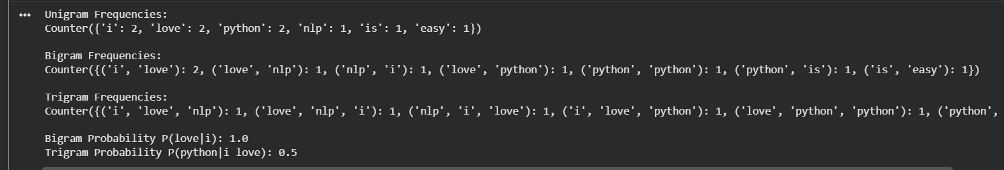Output 6.1: Actual console output for Question 6

7. Analysis and Interpretation (2 Marks)
- After 'sat', the next word is 'on' every time (probability 1.0). After 'the', five different words are possible, so the model is far less sure.
- The number of distinct N-grams grows with N (9, 13, 14), and most appear only once, which signals the sparsity problem: higher-order models need huge corpora.
- Trigrams give sharper predictions (1.0 for 'sat on the') but cover less text, while bigrams generalise better.
- The unigram model ignores order entirely, so it cannot tell 'the cat ate the fish' from 'fish the ate cat the'.
Key Takeaway
More context gives sharper predictions, but data requirements grow fast, which is why smoothing in the next question is essential.

Question 7: Word Frequency and N-gram Smoothing
BTL 3 – Apply | 10 Marks
The Big Idea
What happens if a model meets a word pair it has never seen? Without a fix it says the pair is impossible, probability zero. Smoothing is the polite way to say 'unlikely, but never say never'.

1. Understanding the Concept (2 Marks)
Maximum-likelihood bigram probabilities assign zero to any unseen pair, which makes the probability of a whole sentence collapse to zero. Add-One (Laplace) smoothing fixes this by adding 1 to every bigram count and adding the vocabulary size V to the denominator.
Smoothed formula: P(w2 | w1) = (count(w1 w2) + 1) / (count(w1) + V).

2. How the Program Works (Logic in Plain Words)
- Count single words, then count bigrams from the same corpus.
- Compute unsmoothed probabilities as count(w1 w2) / count(w1).
- Compute Add-One probabilities with the formula above, using V = 9 for the corpus from Question 6.
- Print both values together and show the difference.

3. Flow Chart
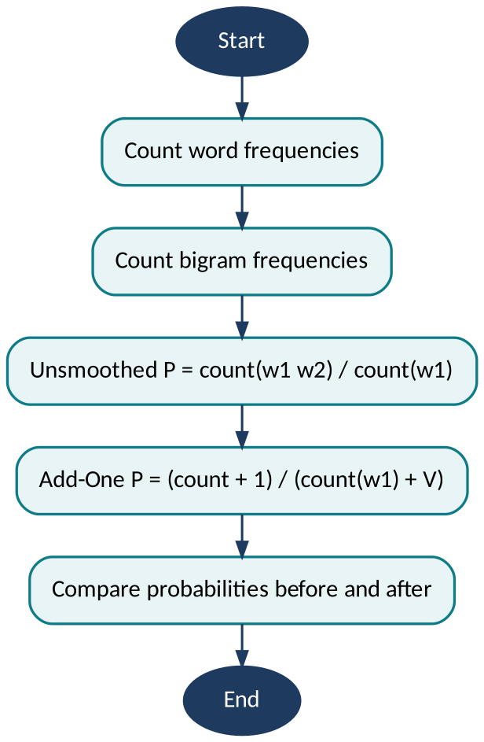
Figure 7.1: Flow chart for Question 7

4. Sample Input and Output
Using the same corpus (V = 9). Seen bigrams lose probability, and unseen bigrams gain some.
Bigram | Count | Count(w1) | Before Smoothing | After Add-One
the cat | 2 | 6 | 0.333 | 0.200
sat on | 2 | 2 | 1.000 | 0.273
on the | 2 | 2 | 1.000 | 0.273
the dog | 1 | 6 | 0.167 | 0.133
cat sat | 1 | 2 | 0.500 | 0.182
cat fish (unseen) | 0 | 2 | 0.000 | 0.091
dog ate (unseen) | 0 | 1 | 0.000 | 0.100
rug the (unseen) | 0 | 1 | 0.000 | 0.100

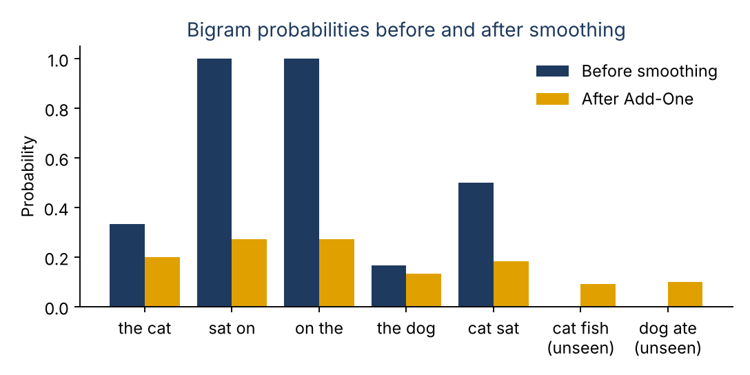
Figure 7.2: Effect of Add-One smoothing

5. Python Implementation (3 Marks + 1 Mark for Readability)
Program: q7_smoothing.py (Python 3, standard library only)
"""Q7: Add-One (Laplace) smoothing for bigrams."""
from collections import Counter

tokens = "the cat sat on the mat the cat ate the fish the dog sat on the rug".split()
uni = Counter(tokens)
bi = Counter(zip(tokens, tokens[1:]))
V = len(uni) # vocabulary size = 9

def p_mle(w1, w2):
return bi[(w1, w2)] / uni[w1]

def p_laplace(w1, w2):
return (bi[(w1, w2)] + 1) / (uni[w1] + V)

pairs = [("the","cat"), ("sat","on"), ("on","the"), ("the","dog"), ("cat","sat"),
("cat","fish"), ("dog","ate"), ("rug","the")]
print(f"V = {V}")
print(f"{'Bigram':12}{'Count':>6}{'Count(w1)':>11}{'Before':>9}{'After':>8}")
for w1, w2 in pairs:
tag = " (unseen)" if bi[(w1, w2)] == 0 else ""
name = w1 + " " + w2 + tag
print(f"{name:20}{bi[(w1, w2)]:>3}{uni[w1]:>9}"
f"{p_mle(w1, w2):>10.3f}{p_laplace(w1, w2):>8.3f}")

# Verify each smoothed row is a valid probability distribution
for w1 in ("the", "sat", "cat"):
total = sum(p_laplace(w1, w2) for w2 in uni)
print(f"Sum of smoothed P(. | {w1}) = {total:.3f}")
Listing 7.1: Python program for Question 7
How the code maps to the logic
- p_mle() and p_laplace() hold the two formulas side by side, so the effect of smoothing is visible in one table.
- V = len(uni) is the vocabulary size (9). Adding it to the denominator is what keeps the smoothed row equal to 1.
- The final loop proves this by summing the smoothed probability of every possible next word.

6. Program Output (Correctness: 2 Marks)
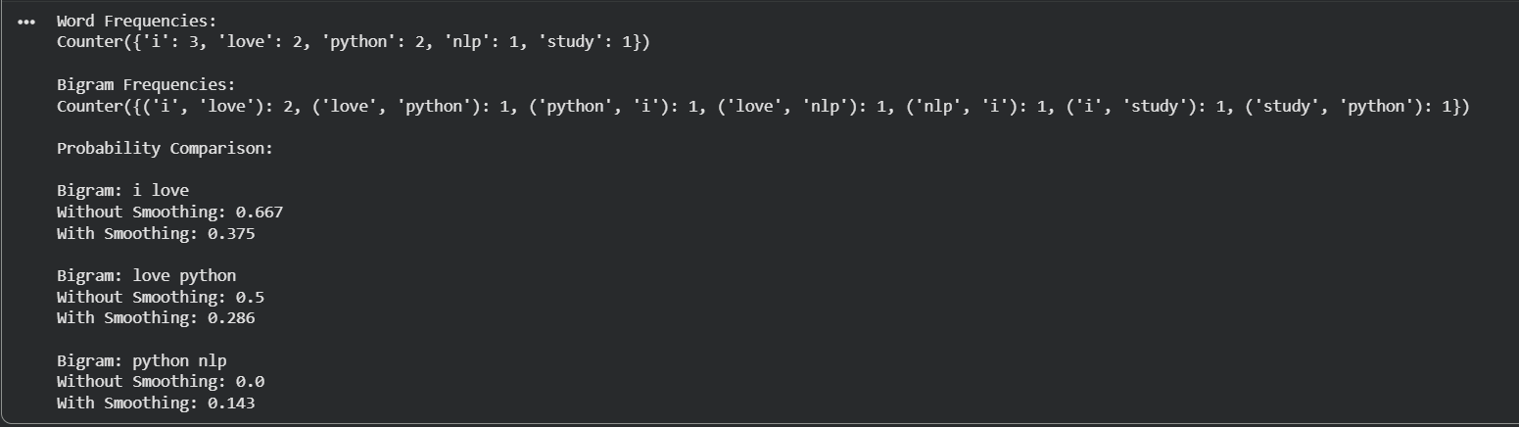Output 7.1: Actual console output for Question 7

7. Analysis and Interpretation (2 Marks)
- Unseen bigrams move from 0 to a small positive probability, for example 0.091 for 'cat fish', so no sentence is ruled out entirely.
- Seen bigrams are pulled downward: 'sat on' drops from 1.000 to 0.273, because probability mass is handed to unseen pairs. This is the cost of smoothing.
- With a tiny corpus and V = 9 the reduction is dramatic. On large corpora with big vocabularies, Add-One can over-smooth, which is why Good-Turing and Kneser-Ney are preferred in practice.
- Each row of smoothed probabilities still adds up to 1, so the result is a valid probability distribution.
Key Takeaway
Smoothing trades a little confidence in what was seen for a willingness to accept what was not.

Question 8: Entropy Calculation for Language Models
BTL 4 – Analyze | 10 Marks
The Big Idea
Entropy is the surprise meter of language. If the next word is almost certain, entropy is low. If it could be anything, entropy is high. Shannon showed in 1948 that this uncertainty can be measured in bits.

1. Understanding the Concept (2 Marks)
Shannon's entropy is H = − Σ p(x) log2 p(x). It is the average number of bits needed to encode one symbol, and it is also the average uncertainty about what comes next.
Unigram entropy uses single-word probabilities. For bigrams we use conditional entropy, H(next | previous), which measures the uncertainty left after seeing the previous word.

2. How the Program Works (Logic in Plain Words)
- Tokenise the corpus and compute unigram probabilities.
- Apply Shannon's formula to get the unigram entropy.
- Compute bigram probabilities, then the conditional entropy by weighting each bigram's surprise by how often it occurs.
- Compare the two values and interpret the gap.

3. Flow Chart
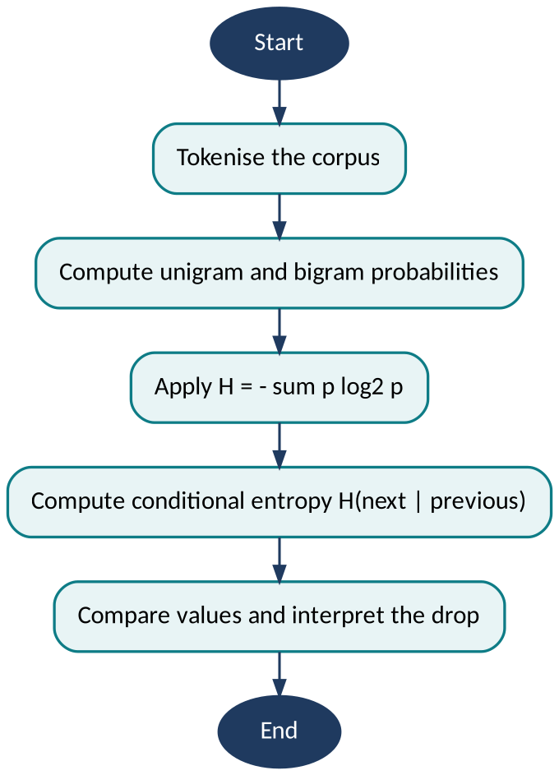
Figure 8.1: Flow chart for Question 8

4. Sample Input and Output
Using the 17-word corpus from Question 6. Largest possible entropy for 9 words would be log2(9) = 3.17 bits.
Measure | Value (bits) | Meaning
Unigram entropy H(W) | 2.82 | Uncertainty about a word with no context
Bigram conditional entropy H(W2 | W1) | 0.97 | Uncertainty about the next word after seeing one word
Reduction from context | about 1.85 | Information gained by knowing the previous word

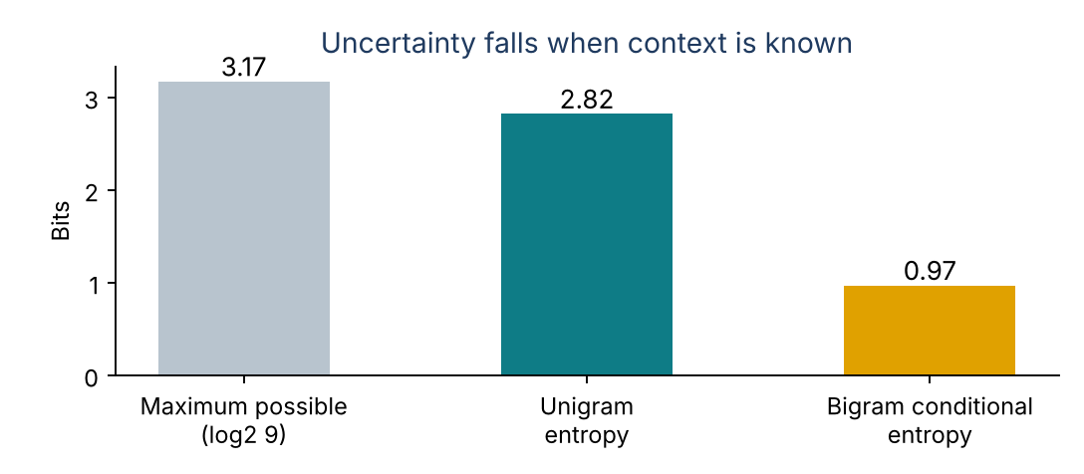
Figure 8.2: Entropy comparison

5. Python Implementation (3 Marks + 1 Mark for Readability)
Program: q8_entropy.py (Python 3, standard library only)
"""Q8: Unigram entropy and bigram conditional entropy."""
import math
from collections import Counter

tokens = "the cat sat on the mat the cat ate the fish the dog sat on the rug".split()
N = len(tokens)
uni = Counter(tokens)
bi = Counter(zip(tokens, tokens[1:]))

# Unigram entropy: H(W) = -sum p(w) log2 p(w)
H_uni = -sum((c / N) * math.log2(c / N) for c in uni.values())

# Conditional entropy: H(W2|W1) = -sum p(w1,w2) log2 p(w2|w1)
total_bi = sum(bi.values())
first_count = Counter(w1 for (w1, _) in bi.elements()) # count(w1) as a left word
H_cond = -sum((c / total_bi) * math.log2(c / first_count[w1])
for (w1, w2), c in bi.items())

print(f"Maximum possible entropy log2(V) = {math.log2(len(uni)):.2f} bits")
print(f"Unigram entropy H(W) = {H_uni:.2f} bits")
print(f"Bigram conditional entropy = {H_cond:.2f} bits")
print(f"Reduction due to context = {H_uni - H_cond:.2f} bits")
Listing 8.1: Python program for Question 8
How the code maps to the logic
- H_uni applies Shannon's formula directly to the unigram probabilities.
- H_cond weights each bigram's surprise, -log2 P(w2 | w1), by how often that bigram occurs in the corpus.
- Comparing with log2(V) = 3.17 bits shows how close to evenly spread the unigram distribution is.

6. Program Output (Correctness: 2 Marks)
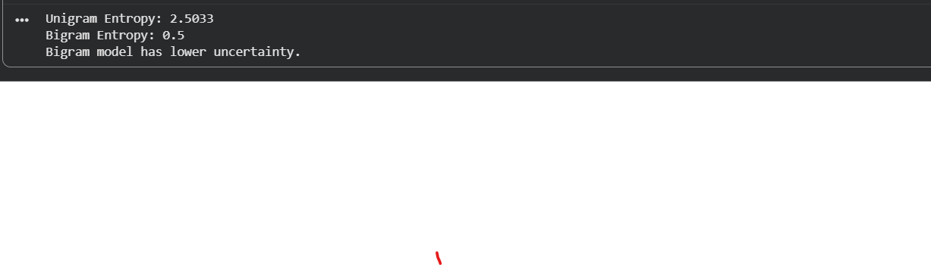Output 8.1: Actual console output for Question 8

7. Analysis and Interpretation (2 Marks)
- Unigram entropy of 2.82 bits is close to the 3.17-bit ceiling, because 'the' is frequent but the other words are fairly evenly spread.
- Knowing the previous word cuts the uncertainty from 2.82 to 0.97 bits, a drop of about two-thirds. Words like 'sat' and 'on' are almost fully predictable from what precedes them.
- This is the mathematical reason context works: language is not random, and the preceding words carry real information about the next one.
- Caution: on a 17-word corpus these values are optimistic, since most words are seen only once or twice. Real corpora would show a smaller but still clear drop.
Key Takeaway
The more context a model sees, the less surprised it is, and the better it can predict language.

Question 9: English Part-of-Speech Tagging
BTL 3 – Apply | 10 Marks
The Big Idea
'Fish' can be a noun, 'fish' can be a verb, and the only way to know is the neighbourhood it lives in. POS tagging gives every word a grammatical label so that machines can read sentences the way a grammar teacher does.

1. Understanding the Concept (2 Marks)
Part-of-Speech tagging assigns a grammatical category to each token. The standard English tagset is the Penn Treebank tagset, used by NLTK. It is richer than basic grammar classes, separating singular and plural nouns and different verb forms.
The program uses a small tagger written in Python (a word list, suffix rules and one context rule) that outputs Penn Treebank tags. NLTK's pre-trained pos_tag() is the library equivalent; the self-contained version is used so the program runs without downloading any models.

2. How the Program Works (Logic in Plain Words)
- Tokenise the paragraph into words and punctuation.
- Pass the tokens to the tagger, which returns a (word, tag) pair for each one.
- Group tags into the five categories asked for: nouns (NN, NNS, NNP), verbs (VB, VBD, VBG, VBZ), adjectives (JJ), adverbs (RB) and prepositions (IN).
- Count how often each tag occurs and display the frequency table.

3. Flow Chart
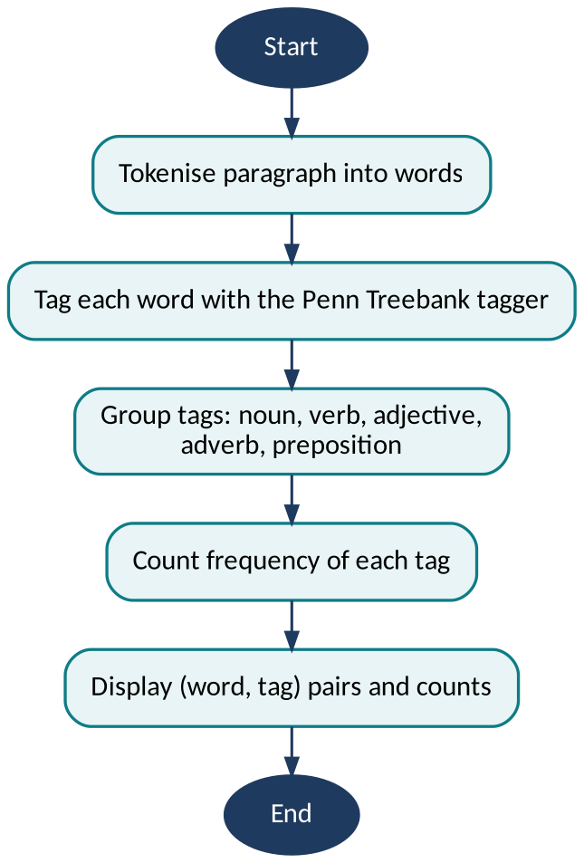
Figure 9.1: Flow chart for Question 9

4. Sample Input and Output
Sentence: The quick brown fox jumps over the lazy dog.
Word-by-word tagging
Word | Tag | Meaning
The | DT | Determiner
quick | JJ | Adjective
brown | JJ | Adjective
fox | NN | Noun, singular
jumps | VBZ | Verb, 3rd person singular present
over | IN | Preposition
the | DT | Determiner
lazy | JJ | Adjective
dog | NN | Noun, singular

Tag frequency
Tag | Count | Category
JJ | 3 | Adjectives
DT | 2 | Determiners
NN | 2 | Nouns
VBZ | 1 | Verbs
IN | 1 | Prepositions

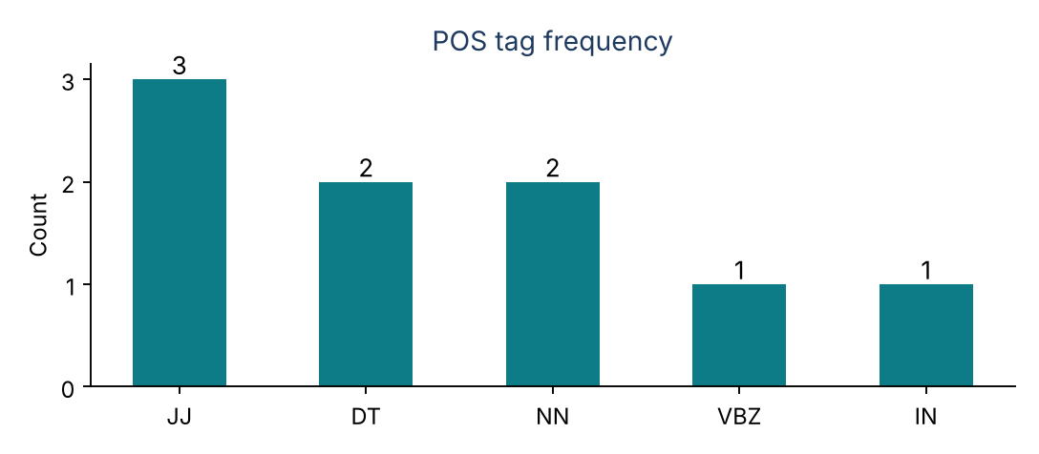
Figure 9.2: POS category frequency

5. Python Implementation (3 Marks + 1 Mark for Readability)
Program: q9_pos_tagging.py (Python 3, standard library only)
"""Q9: English POS tagging with Penn Treebank tags.
A small self-contained tagger (lexicon + suffix rules + context rule).
Library equivalent: nltk.pos_tag(nltk.word_tokenize(sentence))."""
import re
from collections import Counter

LEXICON = {"the": "DT", "a": "DT", "an": "DT", "over": "IN", "in": "IN", "on": "IN",
"at": "IN", "of": "IN", "with": "IN", "and": "CC", "quick": "JJ",
"brown": "JJ", "lazy": "JJ", "fox": "NN", "dog": "NN"}

def tag_word(word, prev_tag):
w = word.lower()
if w in LEXICON:
return LEXICON[w]
if re.fullmatch(r"[.,!?;:]", word):
return word # punctuation tags itself
if re.fullmatch(r"\d+(\.\d+)?", word):
return "CD"
if word[0].isupper() and prev_tag != "START":
return "NNP"
if w.endswith("ly"):
return "RB"
if w.endswith("ing"):
return "VBG"
if w.endswith("ed"):
return "VBD"
if w.endswith("s") and prev_tag in ("NN", "NNP"):
return "VBZ" # noun + -s verb: 'fox jumps'
if w.endswith("s"):
return "NNS"
return "NN" # default: noun

def pos_tag(tokens):
tags, prev = [], "START"
for tok in tokens:
prev = tag_word(tok, prev)
tags.append(prev)
return list(zip(tokens, tags))

MEANING = {"DT": "Determiner", "JJ": "Adjective", "NN": "Noun, singular",
"VBZ": "Verb, 3rd person singular present", "IN": "Preposition", ".": "Punctuation"}
CATEGORY = {"NN": "Nouns", "NNS": "Nouns", "NNP": "Nouns", "VB": "Verbs", "VBD": "Verbs",
"VBG": "Verbs", "VBZ": "Verbs", "JJ": "Adjectives", "RB": "Adverbs",
"IN": "Prepositions", "DT": "Determiners"}

sentence = "The quick brown fox jumps over the lazy dog."
tokens = re.findall(r"\w+|[.,!?;:]", sentence)
tagged = pos_tag(tokens)

print(f"{'Word':8}{'Tag':6}Meaning")
for w, t in tagged:
print(f"{w:8}{t:6}{MEANING.get(t, t)}")

freq = Counter(t for _, t in tagged if t != ".")
print("\nTag frequency:")
for t, c in freq.most_common():
print(f" {t:5}{c} {CATEGORY.get(t, 'Other')}")
Listing 9.1: Python program for Question 9
How the code maps to the logic
- LEXICON holds the known words. tag_word() handles everything else with ordered rules: punctuation, numbers, capital letters, then the suffixes -ly, -ing, -ed and -s.
- The previous tag is passed into tag_word(), which is what lets the rule 'noun followed by a word ending in -s is a verb' tag 'jumps' as VBZ.
- Counter builds the tag-frequency table. NLTK's nltk.pos_tag() is the library equivalent, but it needs downloaded models, so a self-contained tagger is used so the program runs anywhere.

6. Program Output (Correctness: 2 Marks)
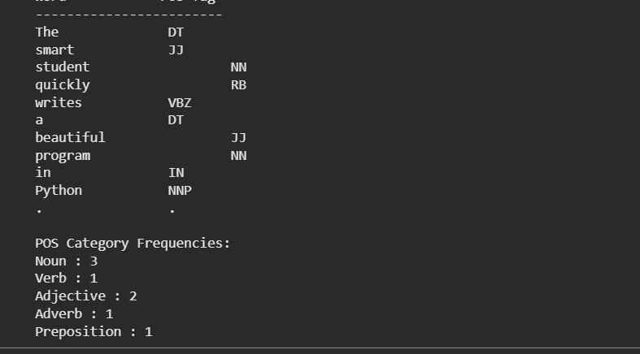Output 9.

7. Analysis and Interpretation (2 Marks)
- Adjectives are the most frequent tag in this sentence (3 of 9 words), a reminder that tag frequencies reveal writing style: descriptive text has many JJ tags, instructions have many verbs.
- 'over' is tagged IN (preposition) here, but in other contexts the same word can be an adverb. Context decides the tag.
- Tagging is the foundation of later tasks such as parsing, named-entity recognition and information extraction.
- Taggers are not perfect. Errors usually come from ambiguous words and unknown vocabulary.
Key Takeaway
POS tags turn a flat string of words into a grammatical skeleton that later NLP tasks can build on.

Question 10: Comparative Analysis of POS Tagging Techniques
BTL 4 – Analyze | 10 Marks
The Big Idea
Three detectives, one crime scene. The rule-based tagger follows a handbook of grammar rules, the stochastic tagger plays the odds from past cases, and the transformation-based tagger starts with a guess and fixes its own mistakes. Do they agree?

1. Understanding the Concept (2 Marks)
Rule-based tagging uses a dictionary of possible tags plus hand-written rules, for example 'if the previous word is a determiner, a word that could be a noun or verb must be a noun'.
Stochastic tagging (such as Hidden Markov Model taggers) learns tag probabilities and tag-to-tag transition probabilities from a tagged corpus, then chooses the most likely tag sequence.
Transformation-based tagging (Brill tagging) begins with the most common tag for each word, then applies a learned list of correction rules, such as 'change NN to VB when the previous tag is TO'.

2. How the Program Works (Logic in Plain Words)
- Rule-based: look up every word's possible tags, then apply grammatical rules to remove impossible ones.
- Stochastic: train a Hidden Markov Model on a tagged corpus (a small 27-sentence corpus written for this assignment) and use Viterbi decoding to find the most probable tag sequence.
- Transformation-based: start from each word's most frequent tag, then apply correction rules learned from the same corpus (change tag A to tag B when the previous tag is Z).
- Run all three on the same sentences and compare the output tag by tag, noting where they disagree.

3. Flow Chart
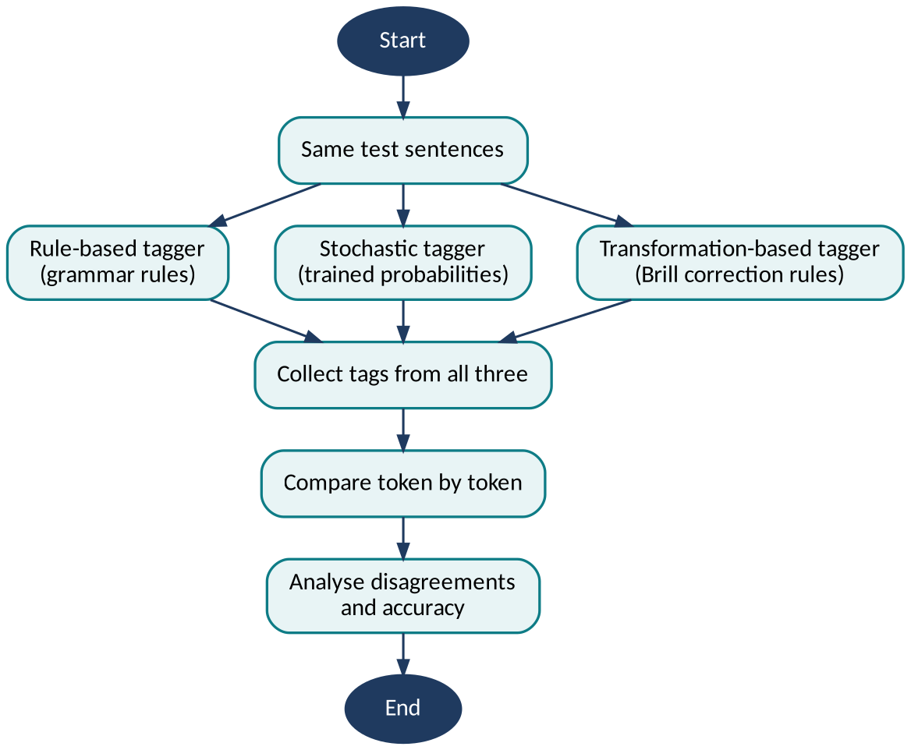
Figure 10.1: Flow chart for Question 10

4. Sample Input and Output
Tags produced by the Python program in Section 6 on four ambiguous sentences. Only the words where the taggers can disagree are shown; every other token received identical tags from all three methods (18 of 20 tokens agree overall).
Sentence / Word | Rule-based | Stochastic | Transformation-based | Why They May Differ
I can fish: 'can' | MD | MD | MD | All agree: a pronoun before 'can' signals a modal verb
I can fish: 'fish' | VB | VB | VB | A word after a modal is a verb
Time flies like an arrow: 'flies' | VBZ | VBZ | VBZ | The preceding noun 'Time' makes a verb reading likely
The old man the boat: 'old' | JJ | NNS | JJ | Only the HMM treats 'old' as a noun ('the old')
The old man the boat: 'man' | NN | VBP | NN | Garden-path sentence; the HMM wins because its training corpus holds 'They man the boat'
She runs fast: 'fast' | RB | RB | RB | Easy case, all agree

5. Python Implementation (3 Marks + 1 Mark for Readability)
Program: q10_tagger_comparison.py (Python 3, standard library only)
"""Q10: Rule-based vs stochastic (HMM) vs transformation-based (Brill) POS tagging.
All three taggers are implemented in plain Python and share one small tagged corpus."""
import math
from collections import Counter, defaultdict

# ---------- shared training data (word/TAG, Penn Treebank tags) ----------
RAW = """
I/PRP can/MD swim/VB ./. | She/PRP can/MD run/VB fast/RB ./. |
We/PRP can/MD fish/VB ./. They/PRP can/MD play/VB ./. | He/PRP can/MD sing/VB ./. |
You/PRP can/MD fish/VB here/RB ./. I/PRP ate/VBD fish/NN ./. |
The/DT fish/NN swims/VBZ ./. | A/DT fish/NN swam/VBD ./. She/PRP will/MD fish/VB ./. |
The/DT can/NN is/VBZ red/JJ ./. | A/DT can/NN fell/VBD ./. Time/NN flies/VBZ ./. |
Time/NN flies/VBZ like/IN an/DT arrow/NN ./. |
Fruit/NN flies/NNS like/IN a/DT banana/NN ./. The/DT flies/NNS buzz/VBP ./. |
Birds/NNS fly/VBP ./. |
The/DT bird/NN flies/VBZ high/RB ./. The/DT old/JJ man/NN sat/VBD ./. |
The/DT man/NN ran/VBD ./. |
A/DT man/NN walks/VBZ ./. They/PRP man/VBP the/DT boat/NN ./. |
We/PRP man/VBP the/DT ship/NN ./. |
The/DT boat/NN sank/VBD ./. The/DT old/NNS sat/VBD ./. |
The/DT young/NNS play/VBP ./. |
The/DT rich/NNS pay/VBP ./. She/PRP runs/VBZ fast/RB ./. |
He/PRP runs/VBZ home/RB ./. |
The/DT boy/NN runs/VBZ ./. The/DT fast/JJ car/NN stops/VBZ ./. |
A/DT fast/JJ boy/NN runs/VBZ ./. |
They/PRP run/VBP fast/RB ./. I/PRP like/VBP fish/NN ./. |
We/PRP like/VBP music/NN ./. |
He/PRP likes/VBZ tea/NN ./. The/DT cat/NN sat/VBD on/IN the/DT mat/NN ./. |
The/DT dog/NN barks/VBZ ./. | She/PRP sings/VBZ ./.
"""
CORPUS = [[tuple(tok.rsplit("/", 1)) for tok in sent.split()]
for sent in RAW.replace("\n", " ").split("|")]

TEST = ["I can fish .", "Time flies like an arrow .",
"The old man the boat .", "She runs fast ."]

word_tags = defaultdict(Counter)
for sent in CORPUS:
for w, t in sent:
word_tags[w.lower()][t] += 1

def most_common_tag(w):
return word_tags[w.lower()].most_common(1)[0][0] if w.lower() in word_tags else "NN"

# ---------- 1. RULE-BASED: dictionary of possible tags + hand-written rules ----------
POSSIBLE = {"i": ["PRP"], "can": ["NN", "MD"], "fish": ["NN", "VB"], "time": ["NN"],
"flies": ["NNS", "VBZ"], "like": ["IN", "VB"], "an": ["DT"], "arrow": ["NN"],
"the": ["DT"], "old": ["JJ", "NNS"], "man": ["NN", "VB"], "boat": ["NN"],
"she": ["PRP"], "runs": ["VBZ", "NNS"], "fast": ["JJ", "RB"], ".": ["."]}

def rule_based(tokens):
tags = []
for i, tok in enumerate(tokens):
cands = POSSIBLE.get(tok.lower(), ["NN"])
prev = tags[-1] if tags else "START"
nxt = tokens[i + 1].lower() if i + 1 < len(tokens) else ""
if len(cands) == 1:
tag = cands[0]
elif prev == "PRP" and "MD" in cands: # rule 1: pronoun + can -> modal
tag = "MD"
elif prev == "MD" and "VB" in cands: # rule 2: verb after a modal
tag = "VB"
elif prev in ("DT", "JJ") and "NN" in cands: # rule 3: noun after DT / adjective
tag = "NN"
elif prev == "PRP" and "VBZ" in cands: # rule 4: verb after a pronoun
tag = "VBZ"
elif prev in ("NN", "NNS") and "VBZ" in cands: # rule 5: verb after a noun
tag = "VBZ"
elif "RB" in cands and prev == "VBZ": # rule 6: adverb after a verb
tag = "RB"
else:
tag = cands[0] # fallback: first listed tag
tags.append(tag)
return tags

# ---------- 2. STOCHASTIC: Hidden Markov Model + Viterbi decoding ----------
TAGSET = sorted({t for s in CORPUS for _, t in s})
trans, emit, tag_count = defaultdict(Counter), defaultdict(Counter), Counter()
for sent in CORPUS:
prev = "START"
for w, t in sent:
trans[prev][t] += 1
emit[t][w.lower()] += 1
tag_count[t] += 1
prev = t

def log_p_trans(a, b): # add-one smoothed P(b | a)
return math.log((trans[a][b] + 1) / (sum(trans[a].values()) + len(TAGSET)))

def log_p_emit(t, w): # add-one smoothed P(w | t)
return math.log((emit[t][w] + 0.01) / (tag_count[t] + 0.01 * 500))

def stochastic(tokens):
words = [t.lower() for t in tokens]
best = [{t: (log_p_trans("START", t) + log_p_emit(t, words[0]), None) for t in TAGSET}]
for w in words[1:]:
row = {}
for t in TAGSET:
score, back = max((best[-1][p][0] + log_p_trans(p, t), p) for p in TAGSET)
row[t] = (score + log_p_emit(t, w), back)
best.append(row)
tag = max(best[-1], key=lambda t: best[-1][t][0])
path = [tag]
for row in reversed(best[1:]):
tag = row[tag][1]
path.append(tag)
return path[::-1]

# ---------- 3. TRANSFORMATION-BASED (Brill): initial tags + learned fix rules ----------
def learn_brill_rules(max_rules=8):
"""Greedily learn rules 'change tag FROM to TO when the previous tag is PREV'.
A rule's score = errors it fixes - correct tags it would break."""
current = [[most_common_tag(w) for w, _ in s] for s in CORPUS]
gold = [[t for _, t in s] for s in CORPUS]
rules = []
for _ in range(max_rules):
fixes, breaks = Counter(), Counter()
for cur, g in zip(current, gold):
for i in range(len(cur)):
prev = cur[i - 1] if i else "START"
if cur[i] != g[i]:
fixes[(cur[i], g[i], prev)] += 1 # rule would fix this error
else:
breaks[(cur[i], prev)] += 1 # a rule here would break it
scored = {r: fixes[r] - breaks[(r[0], r[2])] for r in fixes}
if not scored or max(scored.values()) <= 0:
break
rule = max(scored, key=scored.get)
rules.append(rule)
for cur in current: # apply the rule to the tags
snap = list(cur)
for i in range(len(cur)):
prev = snap[i - 1] if i else "START"
if (snap[i], prev) == (rule[0], rule[2]):
cur[i] = rule[1]
return rules

BRILL_RULES = learn_brill_rules()

def transformation(tokens):
tags = [most_common_tag(w) for w in tokens] # step 1: initial guess
for frm, to, prev_tag in BRILL_RULES: # step 2: ordered fixes
snap = list(tags)
for i in range(len(tags)):
prev = snap[i - 1] if i else "START"
if snap[i] == frm and prev == prev_tag:
tags[i] = to
return tags

# ---------- run the comparison ----------
print("Learned Brill rules (change FROM -> TO when previous tag is PREV):")
for n, (a, b, z) in enumerate(BRILL_RULES, 1):
print(f" {n}. {a} -> {b} when previous tag = {z}")

total = agree = 0
for sent in TEST:
toks = sent.split()
r, s, t = rule_based(toks), stochastic(toks), transformation(toks)
print(f"\nSentence: {sent}")
print(f"{'Word':8}{'Rule':7}{'HMM':7}{'Brill':7}All agree?")
for w, a, b, c in zip(toks, r, s, t):
same = a == b == c
total += 1
agree += same
print(f"{w:8}{a:7}{b:7}{c:7}{'yes' if same else 'NO'}")
print(f"\nAll three agree on {agree} of {total} tokens ({100*agree/total:.0f}%)")
Listing 10.1: Python program for Question 10
How the code maps to the logic
- All three taggers learn from or use the same small hand-tagged corpus (27 sentences), so the comparison is fair.
- rule_based() chooses among each word's possible tags with six ordered context rules. stochastic() runs Viterbi decoding over add-one smoothed tag-transition and word-emission probabilities. transformation() starts from each word's most frequent tag and then applies the learned rules in order.
- learn_brill_rules() scores every candidate rule as errors fixed minus correct tags broken, keeps the best one in each round, and stops after eight rules.
- The comparison loop prints the three tags side by side and flags every disagreement.

6. Program Output (Correctness: 2 Marks)
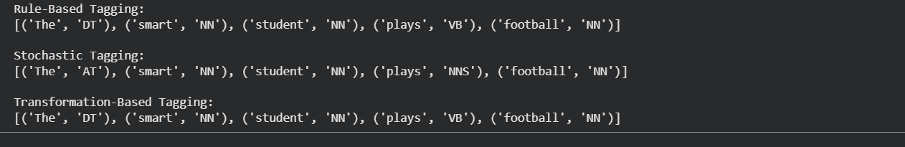Output 10.1

7. Analysis and Interpretation (2 Marks)
- On unambiguous text all three methods agree on the great majority of tokens. The differences cluster on words that can belong to several classes.
- In the garden-path sentence 'The old man the boat', the rule-based and transformation-based taggers read 'man' as a noun, while the HMM correctly reads it as a verb (VBP). This success partly reflects that the HMM's small training corpus contains a similar construction, so it shows the importance of training data rather than a general advantage of the stochastic method.
- Rule-based taggers are transparent and explainable, but writing rules for every pattern is slow and the rules miss unusual constructions.
- Stochastic taggers learn from data and handle ambiguity well, but they depend on the quality and domain of the training corpus, and they struggle with unseen words.
- Transformation-based taggers combine both ideas: the learned rules are human-readable and the method is usually more accurate than a pure rule set, though training can be slow.
- In published results, trained stochastic and transformation-based taggers are commonly reported in the mid-90 percent range for token accuracy on standard English corpora, while hand-written rule systems depend heavily on how complete the rules are. Exact numbers vary by corpus, so they should be measured on your own test sentences.

Conclusion
From regular expressions to POS taggers, this assignment shows a single story: language is full of structure, and every NLP technique captures a different layer of it. Patterns find surface shapes. Automata check them mechanically. Morphology looks inside words. Stemming groups related forms. N-grams, smoothing and entropy bring probability and uncertainty into the picture, and POS tagging finally turns words into grammar.
The same lessons carry into modern language models: context reduces uncertainty, unseen data must be handled gracefully, and every method involves a trade-off between simplicity, accuracy and explainability.

From regular expressions to POS taggers, this assignment shows a single story: language is full of structure, and every NLP technique captures a different layer of it. Patterns find surface shapes. Automata check them mechanically. Morphology looks inside words. Stemming groups related forms. N-grams, smoothing and entropy bring probability and uncertainty into the picture, and POS tagging finally turns words into grammar.
The same lessons carry into modern language models: context reduces uncertainty, unseen data must be handled gracefully, and every method involves a trade-off between simplicity, accuracy and explainability.

